**Commodore VIC-20 Diagnostic User Port PCB Rev. 0**

**Module Description**

The VIC-20 Diagnostics User Port PCB provides most of the required feedbacks for the Commodore Diagnostic Software. Those are the feedbacks for the User Port, the IEC (serial) bus and the Cassette Port. Only the keyboard feedbacks are realized on the Diagnostic Keyboard PCB.

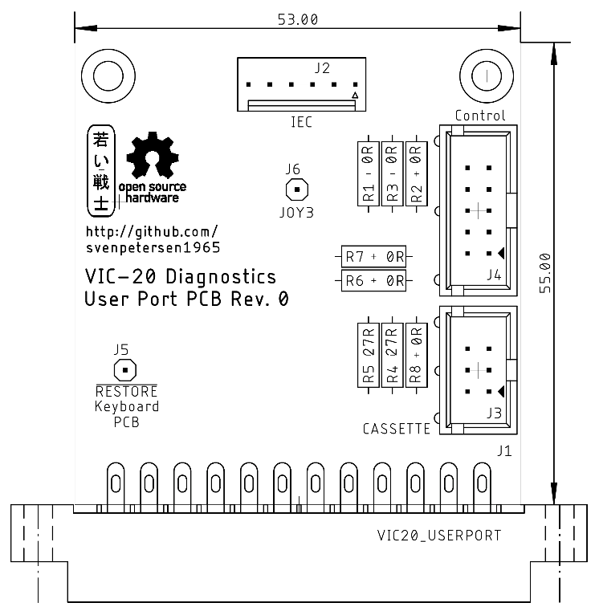

Figure 1: Dimensions of the User Port PCB

# Connectors

## User Port

J1- Edge Connector (2x12, 3.96mm pitch)

|  |  |  |  |
| --- | --- | --- | --- |
| **Pin** | **Signal** | **Pin** | **Signal** |
| 1 | GND | A | GND |
| 2 | +5V | B | CB1 |
| 3 | /RESET | C | PB0 |
| 4 | JOY0 | D | PB1 |
| 5 | JOY1 | E | PB2 |
| 6 | JOY2 | F | PB3 |
| 7 | LIGHTPEN | H | PB4 |
| 8 | CASSSW | J | PB5 |
| 9 | ATN | K | PB6 |
| 10 | 9VAC(1) | L | PB7 |
| 11 | 9VAC(2) | M | CB2 |
| 12 | GND | N | GND |

## IEC-Bus

J2 – KF2510, 6pin (compatible to Molex KK 254 series, 6p. - P/N 22272061)

|  |  |  |
| --- | --- | --- |
| Pin | Signal | DIN 6 |
| 1 | SQR IN | 1 |
| 2 | GND | 2 |
| 3 | ATN | 3 |
| 4 | CLK | 4 |
| 5 | DATA | 5 |
| 6 | n.c | - |

## Cassette Port

J3 – 2x3 pin header for a ribbon cable connected to the cassette port PCB (project number 114, from the C64 Diagnostic Harness).

|  |  |  |  |
| --- | --- | --- | --- |
| **Pin** | **Signal** | **Pin** | **Signal** |
| 1 | GND | 2 | n.c. |
| 3 | MOTOR | 4 | READ |
| 5 | WRITE | 6 | SENSE |

## Control Port

J4 – 2x5 pin header for a ribbon cable which connects via a D-SUB 9 (female) to the control port.

|  |  |  |  |  |  |
| --- | --- | --- | --- | --- | --- |
| **Pin** | D-SUB | **Signal** | **Pin** | D-SUB | **Signal** |
| 1 | 1 | JOY0 (up) | 2 | 6 | LIGHTPEN |
| 3 | 2 | JOY1 (down) | 4 | 7 | +5VCTR1 |
| 5 | 3 | JOY2 (left) | 6 | 8 | n.c. (GND) |
| 7 | 4 | JOY3 (right) | 8 | 9 | POTX |
| 9 | 5 | POTY | 10 | - | n.c. |

# Feedbacks

## User Port (J1)

|  |  |  |  |  |
| --- | --- | --- | --- | --- |
| **Pin** | **Signal** |  | **Signal** | **Pin** |
| B | CB1 | ↔ | IEC-Data | J2/Pin 5 |
| C | PB0 | ↔ | PB1 | D |
| E | PB2 | ↔ | PB3 | F |
| H | PB4 | ↔ | PB5 | J |
| K | PB6 | ↔ | PB7 | L |
| M | CB2 | ↔ | IEC-Clk | J2/Pin 4 |
| 9 | ATN | ↔ | KB | See J5 |

## IEC-Bus (J2)

|  |  |  |  |  |
| --- | --- | --- | --- | --- |
| **Pin** | **Signal** |  | **Signal** | **Pin** |
| 1 | SQR_IN | ↔ | ATN | 3 |
| 4 | IEC-Clk | ↔ | CB2 (User Port) | J1/Pin M |
| 5 | IEC-Data | ↔ | CB1 (User Port) | J1/Pin B |

## Cassette Port (J3)

|  |  |  |  |  |
| --- | --- | --- | --- | --- |
| Pin | **Signal** |  | **Signal** | **Pin** |
| 1 | GND |  | n/c | 2 |
| 3 | MOTOR | Volt.div. | SENSE | 6 |
| 4 | READ | ↔ | WRITE | 5 |

## Control Port (J4)

|  |  |  |  |  |  |  |
| --- | --- | --- | --- | --- | --- | --- |
| **DSub** | **J4 Pin** | **Signal** |  | **Signal** | **J4 Pin** | **DSub** |
| 1 | 1 | JOY0 | ↔ | JOY1 | 3 | 2 |
| 6 | 2 | LIGHTPEN/FIRE | ↔ | JOY2 | 5 | 3 |
| 9 | 8 | POTX | ↔ | +5V (Control Port) | 4 | 7 |
| 5 | 9 | POTY | ↔ | +5V (Control Port) | 4 | 7 |

The JOY3 signal is not tested by the original harness. It is connected to the solder pad J6 for experimental purposes.

## Note

There are a couple of 0Ω resistors on the PCB. They are for leaving the option of inserting a resistor with an impedance >0Ω, in case it might be required in the future. They can be replaced with wire bridges.

# 3D-printed Case

A 3D-printed case for the User Port PCB is available from this repository. The recommended screws are C2.9 x 9.5mm.

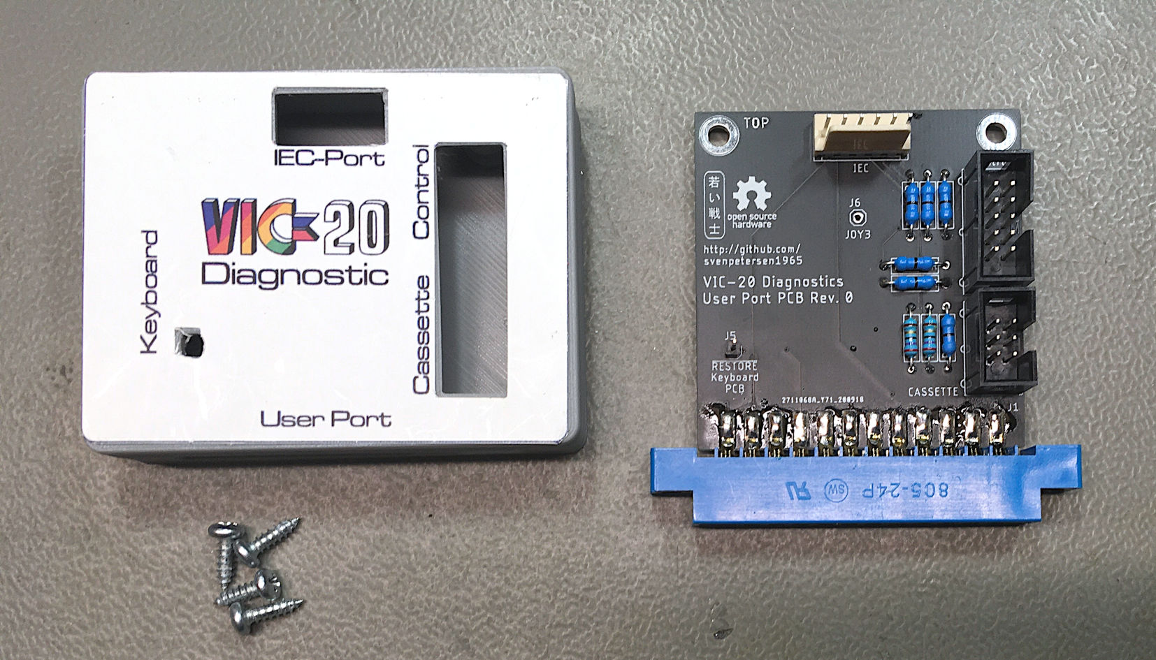

Figure 2: User Port PCB with 3D-printed case